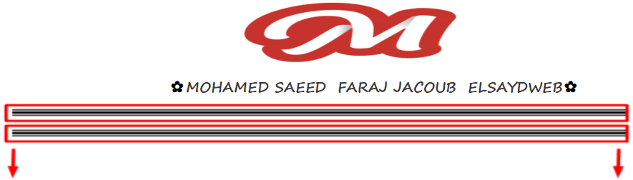

مثال يوضح ازى نستخدم ال HOw to use Font Awesome With css Content

<div class="container">  
 <div class="row wrapper">  
 <p class="mobile">Mobile No</p>  
 <p class="email">Email</p>  
 </div>  
</div>

وده ال css

<style>  
 .wrapper {  
 width:160px;  
 margin:20% auto;  
 }  
  
 p {  
 border:1px solid #666;  
 padding:12px 25px;  
 }  
  
 p.email:before,  
 p.mobile:before{  
 font-family: FontAwesome;  
 display: inline-block;  
 padding-right: 6px;  
 vertical-align: middle;  
 content: "\f003";  
 }  
  
 p.mobile:before {  
 content: "\f095";  
 }  
  
 p.email:before {  
 content: "\f003";  
 }  
</style>

وده مثال يوضح الفكره افضل

<https://codepen.io/bungeedesign/pen/XqeLQg>

وده مثال كمان

<https://stackoverflow.com/questions/20782368/use-font-awesome-icon-as-css-content>

